Vancouver Campus of the Portland VAMC
Date: May 24, 2012
National Task Force Chairman: Ralph Bozella
National Field Service Representative: Steven Henry
Background

In FY 12 3200 FTEE was authorized; 2980 is being shared between the Portland VAMC and Vancouver. The RN to patient ratio is 1:4 and in Long Term Care 1:12. Vancouver has 12,000 unique patients; 72 beds for Long Term Care and for transfer of critical and acute patients and 36 Domiciliary beds. There is a waiting list for beds but not the domiciliary beds. The total budget for FY 11 was 644 million and 670 million in FY 12; this includes OIT, research, regional counsel and all med-care appropriations.

Quality of Care

The Quality Manager Oversees major accreditation preparation/site visits including Joint commission, OIG CAP and CARF. continuous readiness, Risk Management, Performance Measures/Monitors, Cancer Data Center, Credentialing and Privileging OPPE/FPPE data collection, RCA and HFMEA participation with Patient Safety Program, Chart Review data collection for VHA and Joint Commission monitors, Performance Improvement Activities (includes annual poster fair, Strategic Performance, Improvement Forum, PI support on hospital committees and divisions/services, education on tools, Track and maintain all hospital wide policies (Medical Center Memorandums), and Controlled Substance Program

At the Vancouver VAMC Quality is defined as providing appropriate services at the right time and in the right place to maximize health outcome for patients. There is a collaboration with all departments including the Patient Advocate to ensure quality throughout the facility. Quality is monitored through the use of performance measures and surveys including SHEP and Press Ganey that keep the facility in check. By using surveys the facility is able to gain the perspective of the veteran which is then disseminated to the staff through the use of committees. There are 30 committees directed towards quality of care. Any provider who is not meeting performance measures will be expected to develop an action plan to address deficiencies.

With all the time spent on meeting performance measures and adhering to the requests from OIG, CARF and joint commission not enough time is left to dedicate to personal engagement with patients. Implementation of the PACT program has been a difficult process due to staffing shortages; therefore performance measures are not being met on a consistent basis. Currently there is a vacancy for the Systems Redesign Management position; therefore all duties and responsibilities are delegated equally to all management staff. It is a challenge to manage the Quality program and be tasked with System Redesign responsibilities as well; therefore it is imperative that the position be filled as soon as possible.

Patient Safety Officer

The goal of Vancouver’s patient safety program is to reduce or eliminate harm to patients as a result of their care. This program has a direct relation to quality of care; the degree to which health services increase the likelihood of desired health outcomes and are consistent with current professional knowledge.

Vancouver VAMC maintains a “blame free” culture throughout the facility to ensure employees are encouraged to report possible events. There is an anonymous reporting system for those employees who wish to report an event without having to give their name. All Root Cause Analysis are completed within the 45 day mandate; all errors are disclosed to patients increasing transparency throughout the program and facility. Approximately 1000 events are reported on an annually; near misses consist of medication errors, falls and patients that go missing.
Recruiting and retaining top talent is an ongoing challenge throughout the VA. Most notably, the PACT program is unable to meet performance measures due to short staffing. To provide the highest quality of care and maintain patient safety, more staff should be added.
Utilization Manager
The Vancouver VAMC uses a number of indicators to evaluate the quality of care being provided, including readmission rates, variance data from UM (NUMI) software, time on divert, OMELOS, length of stay, patient satisfaction data, and one-day lengths of stay. Biggest challenge is don’t do medical apps and behavior problems. Vent placement, need options for patients with ALS – impossible placements, transferring patients.
The Vancouver Utilization Management program serves as the Point of Contact for the VISN for post discharge calls. When a veteran is discharged he/she is contacted and surveyed in regards to their recent visit to the VAMC including quality of care. Through the post discharge call program the following changes were made:
- Improved meal services
- New TV’s with more channels
- Wireless internet
- Implemented noise free “quiet” areas
- Added additional pharmacists
- Pain management improvements
Information Quality Criteria is built into information criteria – still on FY11 with EPRA and SHEP. Example: Beta blockers are all wrapped into Integral. Need to look at variances and action plans. Not enough beds means less options to move patients to the right level of care. Patients can’t go to next level of care. They can discharge to another part of the hospital, but it may not be the best place for them to go. Staff feedback – compliments from post discharge calls led to initiatives to change pain management.
Risk Manager
The Risk Managers work under Quality & Performance Service and are facilitators of change by networking within the Vancouver VAMC. Their responsibilities include:

  - Examining multiple risk categories and projects, and reporting how a given risk might have implications for the entire organization.
  - Collaborating with the Patient Safety Program to assist with focused reviews, root cause analyses, and healthcare mode effect analyses.
  - Participating in various Medical Center committees that deal with risk, such as Peer Review, Code, and Ethics, is another key component of their role.
  - Collaborating with interdisciplinary groups when writing hospital-wide policies.
  - Reviewing occurrence screens, including: Readmits within 10 days, Admits within 3 days of a clinic visit, Returns to surgery, Inpatient deaths, Outpatient deaths, Suicides, Suicide attempts, Patient codes, Morbidity and mortality reports

Any readmission within 10 days of discharge requires a peer to peer review.

Chief Medical Information Officer
The Vancouver VAMC is VA's leading facility for innovation and the use of technology to improve the quality of care. Technology is used to ensure quality of care by building decision support tools into the electronic medical record. Computers allow the facility to guide clinicians to make decisions based on the best evidence by displaying it to them at key points in the clinical process. Providers are now getting used to using secure messaging through My HealtheVet to communicate with their patients which improves efficiency, quality of care and patient satisfaction.

Patient Satisfaction
The Vancouver VAMC defines Patient Satisfaction as an outcome measure of quality, the patients’ perceptions of one or more aspects of healthcare service delivery experienced at the facility.

Patient satisfaction is measured using a variety of programs and initiatives including the Patient Advocate Tracking System (PATS), the director’s morning meeting which meets on a weekly basis, the Patient Satisfaction Committee that meets quarterly and semi-annually. The facility also uses Survey of Healthcare Experiences of Patients (SHEP) , and Press Ganey. Press Ganey is a private company that is contracted to provide surveys to the facility. Unfortunately data from the SHEP scores take an average of four months to turnover, whereas Press Ganey data is turned over in an average of 30 days.

Director of Patient Care Services
The Director of Patient Care Services is responsible for the professional practice of 950 nursing staff at the medical center’s two campuses and eight Community Based Outpatient Clinics, and for Critical-Care, Critical Care Medicine, Medical-Surgical Units, Emergency Department, Emergency Medical Services, Nursing Research, Nursing Professional Services, Escort, IV and PICC Teams, Respiratory Therapy, Utilization Management, Medical Center Education, Pharmacy, Food and Nutrition Services, Imaging, Laboratory Services, Audiology, Speech Pathology, Chaplain and Social Work Services. Patient Care Services represents a total of 1100 employees and a budget of $152M. Within Patient Care Services is 19 unit based councils; each council has a chair, minutes, goals. Patient satisfaction is reviewed in each unit. Data comes from 2 year strategic plans. There are also nursing committees that discuss research, professional practice, quality care, education and best practices.

Patient satisfaction is tracked through using Daily surveys, Focus Groups, Telephone Responsive survey, SHEP and Press Ganey.

The results of the most recent SHEP scores were:

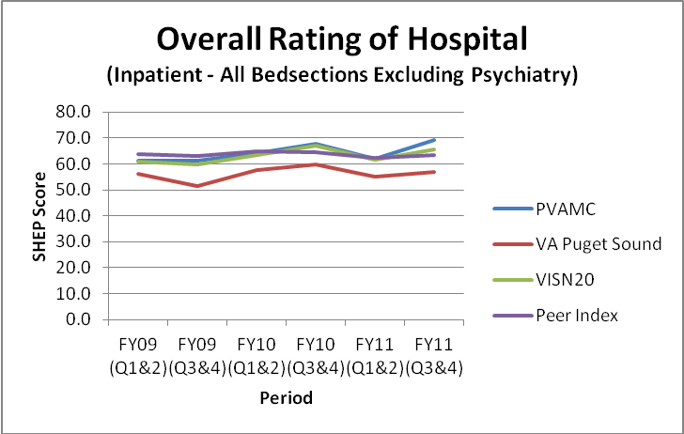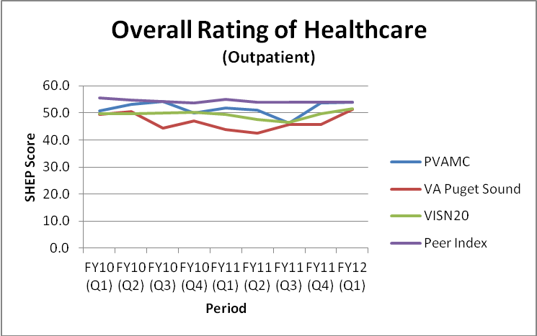

The Vancouver VAMC is a Magnet Facility, a designation from the American Nurses Association for prestigious work in nursing excellence.

Patient Advocate
The Patient Advocate Captures what veterans are saying through surveys and one on one meetings. Each time a veteran communicates a concern to the Patient Advocate it is entered into the PATS system. Surveys and antidotal testimony are used for improving patient satisfaction. Currently Vancouver employs four Patient Advocates and one Patient Relations Officer. New patients know about patent advocacy office – pushes My Health-e Vet for e-management of health care.
- Works closely with VSO’s to get the word out.
- To improve: several “clinical eyes” look at issues. Conduct new beneficiary information, feedback of their tracking system, quality management, patient satisfaction.
- Turnaround 7 days after contact with PA office, call back in 1 day. 1 PC phone system. What happens if patient leaves a message and is not returned called, and has to wait 7 days for resolution to their issue?

PACT Coordinator
PCD leadership and other PVAMC stakeholders attended the National VA Summit in Las Vegas in April 2010 where this transformation was launched. They selected a core “PACT Traveling Team” from the Hillsboro CBOC to participate in the subsequent six national PACT Collaboratives where the Core Team learned the foundational concepts (i.e. building blocks) of PACT and the skills they needed to implement PACT (Medical Home) in their home setting in primary care. They also traveled to our other 10 sites of care educating staff, PCD leadership and our Oversight Board on what they had learned.

